**UNIVERSITY OF DAR ES SALAAM**

**DIRECTORATE OF PLANNING, DEVELOPMENT AND INVESTMENTS**

Development of UDSM's Projects Management Information System (UPMIS)

2nd UPMIS Testing Comments

Date: 22 September 2020

Tested by: F.M. Ishengoma

# **url:** [**http://upmis.udsm.ac.tz**](http://upmis.udsm.ac.tz)

# **Users**

|  |  |  |
| --- | --- | --- |
| **S/N** | **ROLE** | **PRIVILEGES** |
|  | System Administrator | All |
|  | Director DPDI | All |
|  | DVC Administrator | All |
|  | Accountant | All |
|  | ICT Manager | All |
|  | Head of CPTU | CPTU only |
|  | Vote Holder | CPTU only |
|  | Insurance Officer | Insurance only |
|  | DPDI Planner | Real Estate only |
|  | CPTU Manager | CPTU only |
|  | Principal planning Officer | All |
|  | Transport Officer-CPTU | CPTU only |
|  | Liason Officer | All |
|  | Car Rental Officer | CPTU only |
|  | Investments Manager | All |

**Registered Users and Their Roles**

| **S/N** | **USER NAME** | **NAME** | **ROLE** |
| --- | --- | --- | --- |
|  | sadmin | System Admin | System Administrator |
|  | lvenant | Liberato Venant | Director DPDI |
|  | dmfinanga | David Mfinanga | DVC Administrator |
|  | mkissaka | Mussa Kissaka | Vote Holder |
|  | slwiza | Samson Lwiza | Transport Officer-CPTU |
|  | caccountant | CPTU Accountant | Accountant |
|  | hcptu | Head CPTU | Head of CPTU |
|  | uuser | upmis user | Accountant |
|  | ctarimo | Charles Tarimo | ICT Manager |
|  | iofficer | Insurance Officer | Insurance Officer |
|  | egeorge | Eric George | DPDI Planner |
|  | araymond | Alfeo Raymond | Accountant |

**Logged in as Dircetor, DPDI**

* In the summary of spaces:
  + Total spaces is 24, Occupied=8, available 17. Total of occupied and available is 17+8=25 which is greater than total spaces. Find why there is a difference.

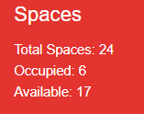The summary for rented spaces, representation of information in terms of percentage might be more meaningful. i.e percentage of rented spaces in each month.

* When editing profile, after clicking **Save** button, if editing is suscessful, redict to page for viewing the profile (not editing). Currently, after clicking Save, the screen stays in profile editing mode.
* When changing password, a **Cancel** button is required if the user want to cancel the operation of the changing the password. Also I suggest to change the label of button from **Submit** to Change or Save. You can improve further by adding red stars (**\***) for the three labels to that they are compulsory.

**Space**

* 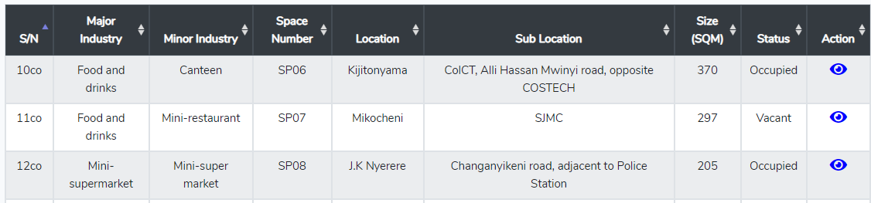S/N column, check if it is OK. It is showing something like **10co**, 11co, 12co,…
* Add a label at the top of the listing to show that the records belongs to **space** as you have done to other menus (such as clients, invoices, etc). See Figure below for Insurance

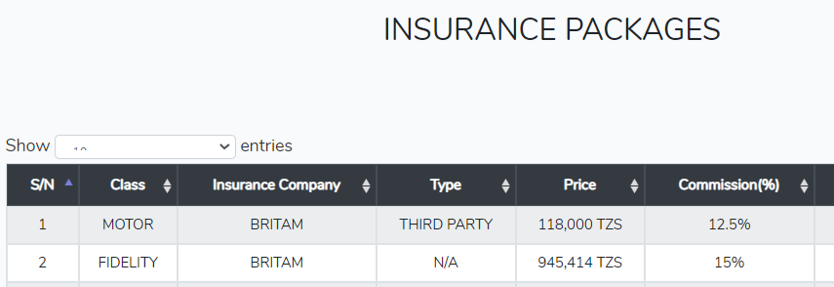

Filtering ???? Check Kigombola's earlier comments

**Car Rental**

* According to DPDI, charges for hiring vehicles are all in Tshs. Hence the column Hire rate/KM can be modified so that the word Tshs is in the column header instead of appearing in every cell in that column.

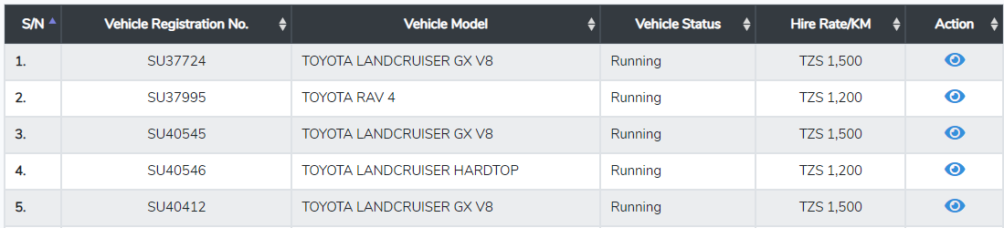

* When displaying details of the vehicle, Add the word Tshs in front of amount

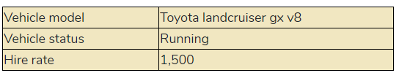

Also add word Tshs/KM in the heading of Hire rate in the following Table. Do the same for other tables which have similar column. Example, the table of showing available vehicles.

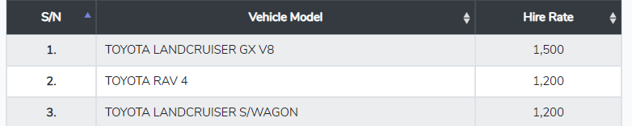

**Clients**

* 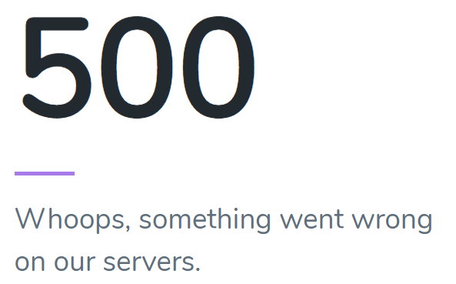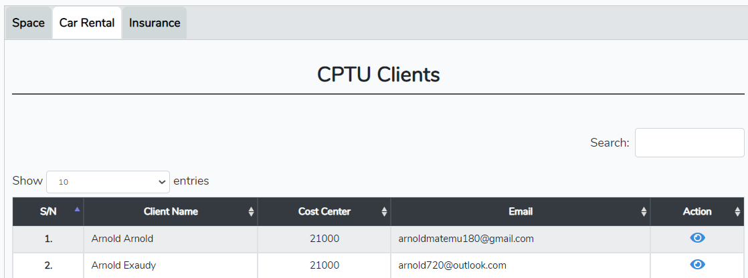Clients > Car Rental , when I click on action button, it results into an exception. Please check.
* You have **active** clients for space, Car Rental and Insurance. Do you have **Inactive** clients for the same or all inactive clients are lumped in one group?

**Contracts**

* For each category of contracts, I think those expired/terminated should appear in a separate Tab instead of showing all contracts from the database. In the same table.

**Invoices**

**Reports**

* Check possibility of adding page numbers on generated reports
* There is no need of words: **Fill all form field with (*)** since you have already indicated those fields with *.
* No need of bolding S/N columns in all reports and all views
* The button **Submit** can be changed to **Generate** since you are generating reports

**Logged in as administrator**

**Car Rental**

* 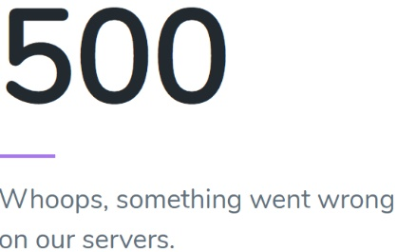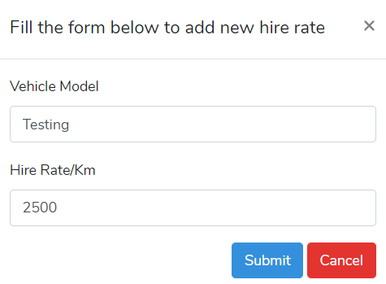**Car Hire > Add Rate**. When Submit button is clicked after specifying the vehicle model and Hire rate/Km it causes an exception.

**Clients**

* **Clients > Car Rental >Add Client**: In the resulting Vehicle Requisition Form, The Cost centres are according to faculty/Department/Unit.

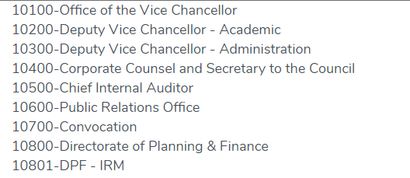

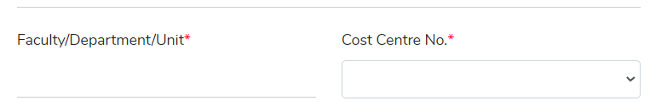Therefore, the system can be programmed so that Faculty/Depart,ent/Unit is filled automatically once a cost centre No. is specified.

**Invoices:**

* Change the + sign for adding a new invoice to be consistent with other areas where you use words in adding something. For example, when adding a new invoice for Real Estate, the button can be labelled "**Add New Invoice for Real Estate**".



**Payments:**

* For adding new payments button, do the same as recommended in Invoices above.

**Reports:**

* Reports which contains currency amount, align the figures to the right instead of left.

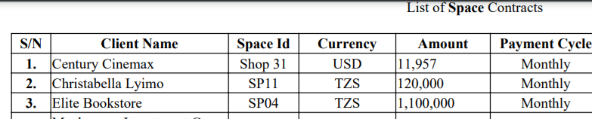

**System Settings:**

* **Users and Role management**
  + + button, add a label as recommended earlier
* **Real Estates**
  + Currently, when it is clicked, it causes 404 error



* **Insurance, Car Rental, Clients, and Reports**: Seems so far there is nothing to configure or not yet implemented

**Note**: Instead of users and role management to be inside the system settings, it can be independent menu and be called say "Manage Users".

Logged in as accountant (araymond)

* Check the roles of account. Is he/she allowed to add space, add insurance package, contracts, etc? Currently he/she can.

Logged in as Transport Officer

* When a vehicle is grounded permanently (no longer in use), is it deleted or deactivated?
* Is there a means to generate a report which shows amount not paid, who have not paid and total amount?
* In the car invoice action column, receive payment is for those who have totally not paid. What about those who have partially paid?
* It seems you can send emails to one client at a time. Think about sending say same email to selected clients (more than one). That means you need a column with check box where you can select more than one client. This applies to other modules where you might need to send an email to multiple clients.

Logged as Vote holder

* 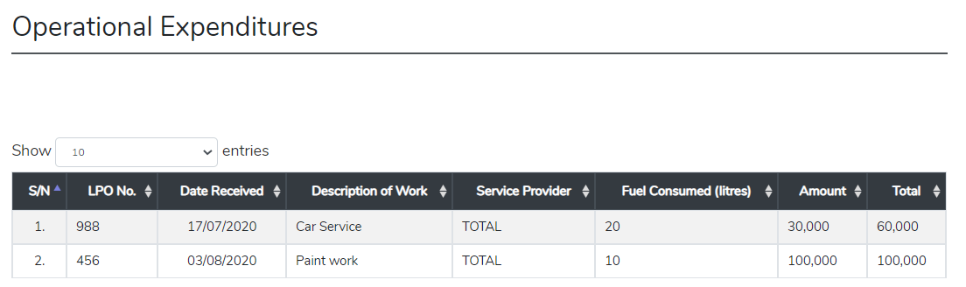Countercheck on the features which the vote holder is supposed to see. For example, is he supposed to see operational expenditures of vehicles (see below). I think other features does not belong to vote holder.

Extra comments

* In System testing No. 1 (August 2020), it was suggested:

Space Number should be created automatically by the system in a systematic approach e.g. VL001, VL002 (if type is Villa) or SHP001 (If type is Shop)

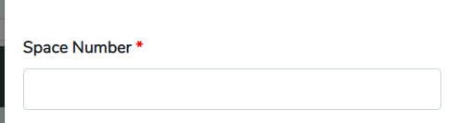Currently the space number is specified by user, and there is no hint about the format of the space number.